Prime Area: Physical Development
- Move confidently in a range of ways, safely negotiating space
- Begin to develop team work through playing team games requiring co-ordination and control
- Handle equipment and tools effectively, including pencils for writing –cursive style
- Know the importance for good health of physical exercise, and a healthy life 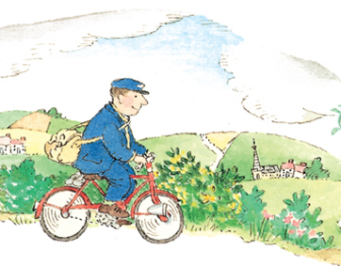
- Begins to talk about ways to keep healthy and safe
Prime Area: Personal, Social & Emotional Development

- Take care of the world around us
- Play co-operatively, taking turns with others
- Develop empathy e.g take account of one another’s ideas
- Confident to try new activities, and say why they like some activities more than others
- Work as part of a group or class, and understand and follow the rules
- Children explore their feelings and understand some behaviour is unacceptable
- Embed Growth Mindset

EYFS – SEVEN AREAS OF LEARNING : MEDIUM TERM PLAN BASED ON THE CHARACTERISTICS OF EFFECTIVE LEARNING: PLAYING & EXPLORING; ACTIVE LEARNING & CREATIVE AND CRITICAL THINKING.
Prime Area: Communication & Language

- Independently follow instructions involving several ideas or actions
- Give their attention to what others say and respond appropriately, while engaged in another activity.
- Develop listening skills to accurately anticipate key events and respond with relevant comments, questions or actions
- Explain own ideas by linking events
- Children express themselves effectively, showing awareness of listeners’ needs

Literacy

- Use some clearly identifiable letters to communicate meaning -using cursive style
- Read and understand simple sentences
- Use phonic knowledge to decode regular words and read them aloud accurately
- Use phonic knowledge to write words in ways which match spoken sounds
- Begin to write some irregular common words
- Attempt to write short sentences in meaningful contexts
- Begin to write simple sentences which can be read by themselves and others
- Know that information can be retrieved from books and computers
Mathematics

- Use developing mathematical ideas and methods to solve practical number based problems
- Recognise, count, order and use numerals up to 20.
- Use a range of strategies for addition and subtraction
- Problem solving involving measures, time, and money
- Estimate number of quantities and check by counting

Understanding of the World

- Begin to explore similarities and differences in relation to places and living things
- Explore features of their own immediate environment and how environments might vary from one another
- Explore how we can maintain our own area and actions that support our communities
- Explore similarities and differences between themselves and others and among families
- Use technology to support understanding
- Develop scientific concepts such as sinking and floating
Expressive Arts & Design

- Use what we have learnt about media and materials in original ways, thinking about uses and purposes
- Create own textured displays linked to travel and journeys
- Represent own ideas, thoughts and feelings through design and technology, art, music, dance, role play and stories
- Explore music around the world as part of our Journeys theme
- Learn an African song with actions for the Lion KIng

TOPIC:
Let’s travel and go on a Journey!
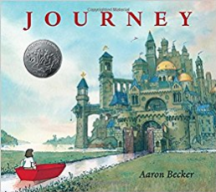

Underwater Class

TERM: 5

2017


