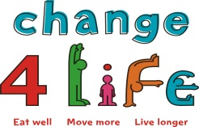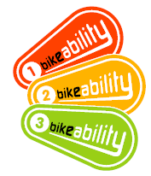

**What is Bikeability Level 1?**

Bikeability Level 1 is an exciting and fun introductory course designed to help improve children’s cycling. They will learn cycling skills to give them confidence on their bike. The course is outcome based and all outcomes must be met to achieve Bikeability Level 1. For those pupils that do not achieve all the Level 1 outcomes their instructor will explain why and indicate where further practice is needed on the ‘Nearly There’ letter that they will be given.

Please note children taking part in Bikeability level 1 must be able to ride a bike unaided. If your child is unable to ride why not book them on to one of our beginner’s courses at Eastbourne Cycle Centre, Cross Levels Way, Eastbourne BN21 2UF.

**What will my child be doing?**

* Fun activities to help develop bike control (for more details click on Bikeability link below)
* bike skills
* Learn how to use gears
* Lean how to fit a helmet properly
* Carrying out simple bike checks

**How much will it cost?**

The course will cost only £7.50 and includes up to 2 hours of fun cycling skills within the school grounds.

**What should I do next?**

* Complete the booking form and consent letter
* Return the completed form with payment to your class Teacher or school office
* **CHEQUES MADE PAYABLE TO THE SCHOOL**

**What do I need to have for my child to take part?**

* A bike with 2 working brakes and no stabilisers
* A correctly fitted helmet
* Suitable clothing for weather on the day ( i.e: Lightweight waterproofs if wet and gloves if cold)
* Sun cream to protect from sunburn when hot
* Sensible footwear

All courses are delivered by East Sussex County Council qualified National Standard trained Cycle Instructors, who are all D.B.S checked For more information regarding Bikeability Level 1 go to [www.bikeability.org](http://www.bikeability.org)

HAPPY CYCLING!!!!

***All courses that the Road Safety Team offer are also available during school holidays at Eastbourne Sports Park. To find out more regarding costs and how to book your place, contact*** [***cycletraining@eastsussex.gov.uk***](mailto:cycletraining@eastsussex.gov.uk)

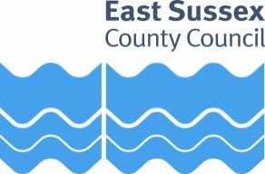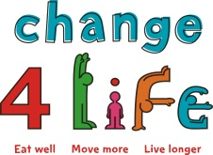

**BIKEABILITY LEVEL 1 - CONSENT FORM**

***Cycling Proficiency for the 21st Century***

**School:** …LAUGHTON CP SCHOOL.

**Date of Course:** …MONDAY 26THMARCH 2018 **Course Times:** …MORNING

**Course Duration**:up to2 hours  **Cost** £7.50

**Please return the signed consent form to the school to confirm your booking.**

**Payment for the course: PLEASE MAKE CHEQUES PAYABLE TO YOUR SCHOOL**

**Child's Name:** …………………….……………………………………………………. **Class:** …………………………………………

**Parent/Guardian's Name**: ……………………………………………………………………………

**Contact Number:** …………………………………….………………………………………………….

**Email address:** …………………………………………………………………………………………….

I agree for my child to have photos taken for media promotion of the event

I give permission for my child to take part

My Child is able to ride a bike unaided

**Signed:** ........................................................... (Parent/Guardian)

**Date:** ................................

Please let us know if your child has any special requirements (medical or behavioural) that the cycle trainers will need to be made aware of, or that may have an impact on their cycling ability.

Please provide details below including any medication that your child may require during the course:

………………………………………………………………………………………………………………………………………………………………………………………………………………………………………………………………………………………………………………………………………………

**PLEASE NOTE CYCLE TRAINERS ARE FIRST AID TRAINED BUT ARE NOT TRAINED TO ADMINISTER MEDICATION; OTHER ARRANGEMENTS WILL HAVE TO BE MADE VIA THE SCHOOL**