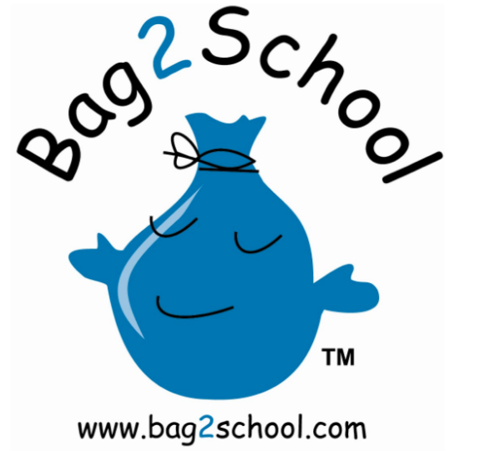

**What we can take… Unwanted but  
good quality**

* Men’s, Ladies’ and Children’s clothing
* Paired shoes (tied together or elastic band around)
* Handbags
* Hats
* Bags
* Scarves and ties
* Jewellery
* Lingerie
* Socks
* Soft toys
* Household linen
* Curtains
* Towels
* Bedding (bed sheets, pillow cases and duvet covers)

### **All bags to school hall on morning of**

### **Monday 22nd January**

**Attention!**

**Unload your unwanted clothes and Help the LSA raise funds.**

**Having a New Year’s clear out? The LSA is preparing for another collection for Bag2School, for which the school receives funds in return. See below for examples of accepted items and check out the** [**Bag2School**](http://uk.bag2school.com/what-we-collect) **website for full details.**

22 January 2018