* **Science**
* Explain that we need light to see things, and that dark is the absence of light.
* Explain reflection and identify reflective materials.
* Use a mirror to reflect light and explain how mirrors works.
* To explain why mirrors are good reflectors.
* To understand that light from the sun can be dangerous and that there are ways we can protect our eyes.
* To explain the benefits and dangers of the sun.
* To explain how a shadow is formed.
* To plan and set up an investigation about the way shadows change size and observe patterns in the way shadows change size.

**P.S.H.E**

Media and Stereotyping

**Geography**

* Name the continents of the world.
* Ask and answer geographical questions about the physical and human characteristics of a location.
* Explain own views about locations, giving reasons.
* Use maps, atlases, globes and digital/computer mapping to locate countries and describe features.

**MFL**

Language for the classroom

High Peaks

Term 5/6

2016 -2017

What a performance !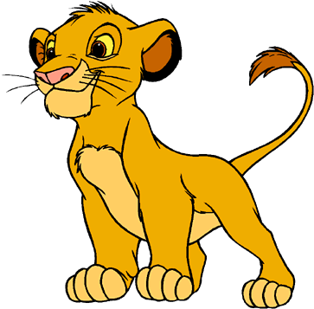

**ENGLISH**

**Reading**

* Apply their growing knowledge of root words, prefixes and suffixes both to read aloud and to understand the meaning of new words they meet
* Identify main ideas drawn from more than one paragraph and summarizing these
* Identifying how language, structure, and presentation contribute to meaning

**Writing**

* Composing and rehearsing sentences orally, progressively building a varied and rich vocabulary and an increasing range of sentence structures
* Assessing the effectiveness of their own and others’ writing and suggesting improvements.
* Proposing changes to grammar and vocabulary to improve consistency, *including the accurate use of pronouns in sentences.*
* *proof-read for spelling and punctuation errors*
* Using commas after fronted adverbials
* Indicating possession by using the possessive apostrophe with plural nouns.
* Using and punctuating direct speech
* GRAMMAR
* indicating possession by using the possessive apostrophe with plural nouns
* SPELLING
  + Recap words with endings sounding like /ʒə/ or /tʃə Endings which sound like /ʒən/ Words ending with the /g/ sound spelt –gue and the /k/ sound spelt –que
* Homophones

**Maths**

* Identify lines of symmetry in 2-D shapes presented in different orientations.
* Complete a simple symmetric figure with respect to a specific line of symmetry
* Identify acute and obtuse angles and compare and order angles up to two right angles by size.
* Draw 2-D shapes and make 3-D shapes using modelling materials; recognise 3-D shapes in different orientations and describe them
* Recognise and show, using diagrams, families of common equivalent fractions.
* Recognise and write decimal equivalents of any number of tenths or hundredths
* Recognise and write decimal
* equivalents to , , 
* Recognise, find and write fractions of a discrete set of objects: unit fractions and non-unit fraction
* Solve problems involving increasingly harder fractions to calculate quantities, and fractions to divide quantities, including non-unit fractions where the answer is a whole number,
* Write and calculate mathematical statements for multiplication and division using the multiplication tables that they know, including for two-digit numbers times one-digit numbers, using mental and progressing to formal written methods.

**Religious Education**

* Births, marriages and Deaths
* Love and marriage

**Physical Education**

* Athletics and Striking and Fielding
* Thursday and Friday

**Music**

* Performance
* African drumming skills and composition