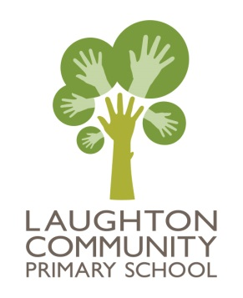
t: 01323811306
e: office@laughton.e-sussex.sch.uk
w: www.laughton.e-sussex.sch.uk
Headteacher: Mrs RM West
Acting Deputy Headteacher: Mrs V Brown

Laughton Community Primary School
Church Lane
Laughton
Lewes
East Sussex
BN8 6AH

20.06.17
Dear Parents and Carers,
As part of our topic KS2 topic ‘What a Performance’ and our Lion King Kids production we have an exciting opportunity coming up for the children to learn how to face paint.
Dee Gibbons, who is the Aunt of Alice, Hamish and Fraser, has kindly offered to come into school and run a workshop in Jungle and High Peaks Classes to show how makeup artists work. These will take place on Wednesday 28th June.

They will be able to watch her model some face painting techniques for animals and then have a go at techniques on each other in small groups.

We know that some children will not be able to have face paints applied to them due to allergies or they may just not like it.
Please could you sign the permission slip below if your child is able to have their face painted and is willing to, we will then ensure that only people with permission are used as models.
We would like the children who are performing in the Lion King Kids to have their faces painted for the production and will start this for the rehearsals in the week beginning 10th July. Please indicate separately on the permission slip if you are happy for your child to have their faces painted for the production.
Thank you for your support.

Kind regards
Rachel West
Headteacher
Face Painting Permission

I give permission/ do not give permission for my child ______________________(please delete as appropriate) to have their face painted at the class workshop on Wednesday 28th June.

My child_____________________________is in the Lion King Kids and I give permission/ do not give permission for them to have their face painted for the production.
Signed _____________________________ Date________________

