Week 1 – Create your own scrapbook or mood board reflecting what makes
YOU A CHAMPION!
This can be added to with your achievements, how you felt, who has helped you along the way and any inspirational quotes.
Below are some ideas of what it could look like, but get creative!
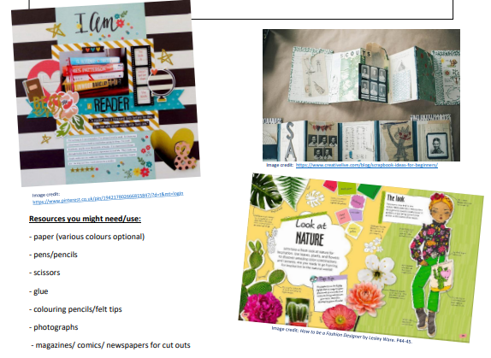
Remember to complete your Mathletics and grammar sheet and read for at least 20 minutes daily.
Reminders:
- PE days are Thursday and Friday
- Children need a named water bottle in school
- Children may need a hat in school on days that are sunny.

Week 2 – Create a Word Cloud by clicking on the link below and adding in words associated with you!
http://www.wordclouds.co.uk
What are you good at? Who is important to you? What qualities do you have? What skills do you possess?
Try to use at least three or four new words (by finding synonyms) to add to your vocabulary.
Play around with how you want the design to look and then save the image. If you are unable to access the website, you can hand draw your Word Cloud.
Remember to complete your Mathletics and grammar sheet and read for at least 20 minutes daily.
Reminders:
- PE days are Thursday and Friday
- Children need a named water bottle in school
- Children may need a hat in school on days that are sunny.

Week 3 – the song Space Oddity by David Bowie http://mrwreads.blogspot.com/2012/03/wonder-part-two-via.html is referenced in the book Wonder. Listen to the song. Choose a song that represents you. Choose three or four bits of the lyrics to analyse and represent. Create a piece of art to present these lyrics in any way you choose.
Remember to complete your Mathletics and grammar sheet and read for at least 20 minutes daily.
Reminders:
- PE days are Thursday and Friday
- Children need a named water bottle in school
- Children may need a hat in school on days that are sunny.

Week 4 – Make a pictoword, like the examples below, which celebrates everything that’s AMAZING about YOU! Be as creative as you wish, you can use any form of art media you wish.
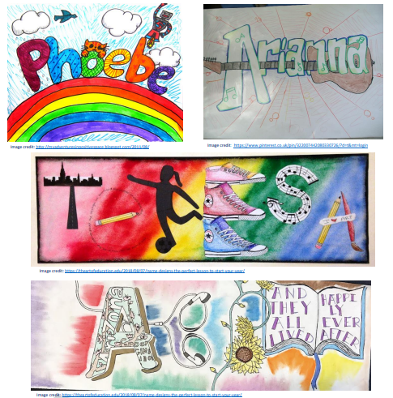
Remember to complete your Mathletics and grammar sheet and read for at least 20 minutes daily.
Reminders:
- PE days are Thursday and Friday
- Children need a named water bottle in school
- Children may need a hat in school on days that are sunny.

Week 5 – When given the choice between being right or being kind, choose kind.
What does this mean? Create a poster, either digitally or by hand to promote the message: Choose kind.
Remember to complete your Mathletics and grammar sheet and read for at least 20 minutes daily.
Reminders:
- PE days are Thursday and Friday
- Children need a named water bottle in school
- Children may need a hat in school on days that are sunny.
Week 6 – Write a poem all about you. It does not have to rhyme but remember to use poetic devices such as: similes, metaphors, personification, onomatopoeia, alliteration, rhyming (if you want to), and rhythm.
Remember to complete your Mathletics and grammar sheet and read for at least 20 minutes daily.
Reminders:
- PE days are Thursday and Friday
- Children need a named water bottle in school
- Children may need a hat in school on days that are sunny.

