I like reading and writing | Ask a grown up what their favourite book was as a child and read it with them.  Share your own favourite book and talk about why you both like them. Write a couple of sentences to tell me about the books. | 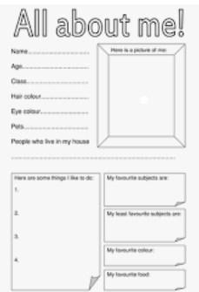  Create a fact sheet all about you. What is your favourite colour? What is your favourite food? What is your favourite song? Etc.  Do you have a special talent? We’d love to hear all about it.
I enjoy maths | Go on a number hunt. You could look in books and magazines, on door numbers, number plates, clocks, price labels, remote controls, phones, calendars or greetings cards. Talk about the numbers you see and record your findings by drawing pictures or taking photos of the numbers you find. |  |  | 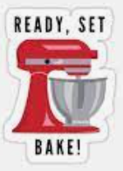  Choose a classic British dish to make or bake. Photograph or bring in your cooking creation to show your friends.  *Adult supervision needed.
I like researching and finding things out. | Find out what activities there are for children to do in our local area and write down a list in your book. This could be going for a walk, going to the park or even a trip to the leisure centre. Make sure you try at least one activity on your list. |  | Ask some members of your family what they liked to do when they were your age.  Write them down and choose some to try with your family. Capture your experiences in a photograph or drawing.
I like to make things and be creative. | Learn about the bones that make your skeleton.  Create a skeleton model using any materials e.g. sticks, pasta, straws. Bring in your model or a photograph of your model.
 | Go outside and see if you can use items you find to create a model of the human body.  Take a photo and bring it in to school. |  |  | 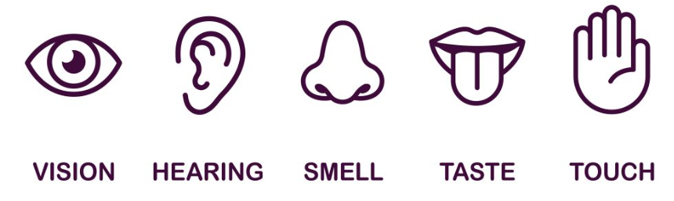  Split your page into 5 parts and draw a picture of something you heard, saw, smelled, tasted and touched over the weekend.
I like to draw and paint. | 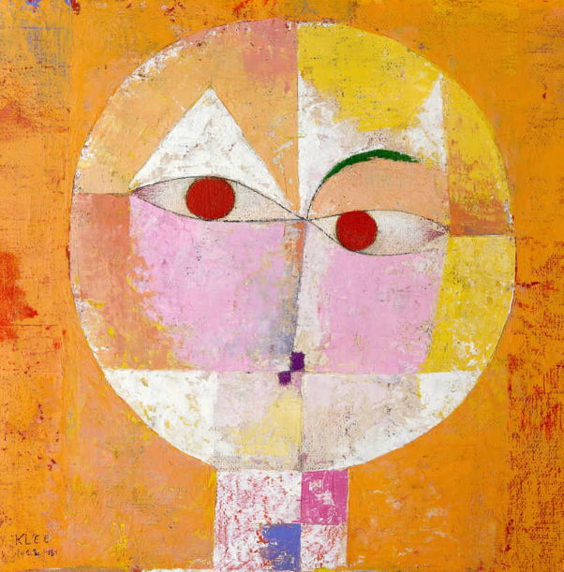  Research the portrait ‘Senecio’ by Paul Klee and create your own self-portrait using his style. |  |  | Either draw, paint or collage the view from your bedroom window. Think about all the things that you can see; do you think you see exactly the same things as your friends?
Wildcard! | Come up with your own homework and explain to the class what you have done and tell us WHY you chose to do what you did!
Please bring in homework books or upload work to eSchools by Wednesday of each week, to be shared in class every Friday.
Year 1 and 2 Homework Grid – Marvellous Me Term 1 2022 Each week you should: complete a quality piece of homework from the grid below, read regularly to an adult and practise key instant recall number facts (little and often is best).

