Prime Area: Physical Development
- Improve control and co-ordination in large and small movements through ‘Dough Disco’ and Continuous Provision (travelling, climbing, ball skills, negotiating space using wheeled vehicles)
- Continue to improve pencil control, leading to more detailed drawings and correct letter formation
- Handle equipment and tools more effectively in all contexts eg scissors and cutlery
- Manage personal needs successfully, and independently
- Explore aspects of a healthy lifestyle, including exercise, food choices, rest and oral hygiene
- Explore balance and managing own body. Be able to stretch, reach, and extend in a variety of ways and positions. Be able to control the body and perform specific movements on command.
- Send and receive a variety of objects with different body parts. Work with others to control objects in space. Coordinate body parts in a variety of activities and in different ways.
- Walk to School Week (20th-24th)

Prime Area: Personal, Social & Emotional Development
- Improve understanding of each of the school values.
- Regulate and adapt their own behaviour in response to different contexts e.g. events, visitors in school.
- Show an understanding of their own feelings and those of others, and begin to regulate their behaviour accordingly. To be able to take turns without an adult.
- Be confident to try new activities and show independence, resilience and perseverance in the face of challenge and in preparation for year 1.
- Able to series of instructions to complete an activity independently
- WWO – Outdoor teamwork challenges

EYFS Topic Web: EYFS Medium Term Planning TERM 5 Spring 2025
EYFS Framework – 3 Prime Areas of Learning and 4 specific areas underpinned by four key themes: A unique child; Positive Relationships; Enabling Environments; Learning and Development
Encompassing the characteristics of effective learning: - playing and exploring, active learning, creative and critical thinking
Through our school values we show kindness, respect, aspiration, perseverance, forgiveness and work together.

Prime Area: Communication & Language
- Listen to topic themed stories, accurately anticipating key events.
- Begin to show awareness of listeners’ needs, giving their attention to what others say and responding appropriately in different contexts.
- Use new vocabulary that they learn from rich texts, from their peers and as modelled by adults
- Use past, present and future forms accurately when talking about events that have happened or are to happen in the future.
- Continue to develop narratives and explanations by connecting ideas or events.
- To understand and ask a question such as who, what, where, when, why and how.

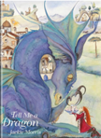
Literacy:
Key Texts: Tell me a Dragon, The Castle the King Built, How to Catch a Dragon, The Paper Bag Princess
- Read and understand sentences using phonic knowledge to decode regular words.
- Demonstrate understanding when talking with others about what they have read.
- Write simple sentences, which can be read by themselves and others.
- Use traditional/fairy tales as an impetus to create their own ‘Once Upon a Time’ style narratives
- Use and understand new vocabulary introduced through fiction and non-fiction texts
- Begin to spell phonetically regular words of more than one syllable as well as many irregular but high frequency words

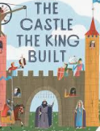
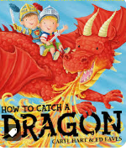
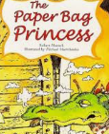

Towers, Tunnels and Turrets
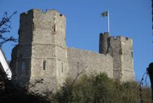
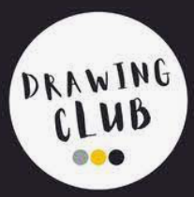
Mathematics: Number and Numerical Patterns
- Use language to sequence events e.g. before, later, yesterday, tomorrow
- Manipulate, compose and decompose shapes.
- Understand the composition of 10 and begin to apply instant recall of these number facts e.g. 6+4, 7+3, 8+2.
- Explore doubles, Odds and evens to 10.
- Know the names and features of 2D and 3D shapes
- Develop patterning skills e.g. symmetrical patterns, sophisticated repeating patterns in the environment eg wallpaper, wrapping paper
- Count to 20 and beyond, recognising the pattern of number including partitioning e.g. how many tens and ones does 12 have?

Understanding the World
- Continue to observe the features of the changing seasons within the local environment
- Describe a series of instructions as a sequence: Explore playing with programmable toys.
- Understand the past through settings, characters and events encountered in books: Find out about Lewes castle and compare and contrast to other castles around the UK and further afield,
- RE: Exploring what places are special and why.
- Recognise that different religious groups have different special places that link them to God.
- Make connections to their own special places.
- Describe how we care for the natural world around us.
- Observe and describe the process of planting and growing seeds.
- Explain the life cycle of human or animal studied e.g. tadpole, chick, caterpillar.

Expressive Arts & Design
- Explore the ‘Towers, Tunnels and Turrets’ theme through role-play and small world characters/setting.
- Action songs linked to dragons and castles.
- Reflect on work and evaluate finished pieces, sharing with peers.
- Explore improvisation: Explore and play with a wide range of media and materials (expressive art)
- Explore the work of Henry Moore- Manipulate malleable materials for a purpose, e.g. pot, tile
- I can explore colour mixing to make tertiary colours.

