Prime Area: Physical Development
- Move confidently in a range of ways, with equipment and around obstacles
- Use a pencil and hold it effectively to form recognisable letters that are correctly formed
- Handle equipment and tools effectively
- Mud and paint mixing – with hands and feet, exploring consistency with African inspired colours and pattern
- African inspired dance and movement, inspired by the topic text, The Greedy Zebra
- Manage personal needs successfully, and independently
- Exploring healthy food choices and considering the impact on oral hygiene

Prime Area: Personal, Social & Emotional Development
- Understand and respect others who may not agree with you: ‘What is your favourite animal? Why?’
- Take account of one another’s ideas about how to organise an activity e.g. role-play or a focused learning task
- Develop self-awareness of their own feelings in different scenarios and show sensitivity to the feelings of others
- Select own resources needed for a given activity and know how to seek support from a variety of sources, if needed
- WWO – giving and receiving feedback

EYFS Framework – 3 Prime Areas of Learning and 4 specific areas underpinned by four key themes: A unique child; Positive Relationships; Enabling Environments; Learning and Development As part of our Growth Mindset approach we are collaborative, resilient, disciplined, imaginative and curious learners

Prime Area: Communication & Language
- Respond to what they hear with relevant comments and/or questions, explaining their thoughts and opinions
- Answer ‘how’ and ‘why’ questions in response to stories, events and guessing games (e.g. What animal am I?)
- Follow instructions involving several ideas or actions; give similar instructions to others
- Communicate effectively in role-play scenarios (vet role play, Christmas market role play)
- Participate in ‘Show and Tell’ either talking about an item brought from home, or asking relevant who, why, how, what questions.

Literacy: Comprehension, Word Reading and Writing
Texts:- Greedy Zebra, The Tiger Who Came to Tea, Handa’s Surprise,
One Day on Our Blue Planet, The Hunter, Meerkat Mail, Giraffes Can’t Dance,
- Read and understand sentences using phonic knowledge to decode regular words
- Demonstrate understanding when talking with others about what they have read
- Begin to write words which can be read by themselves and others: create a fact file about their favourite animal/re-tell a familiar story
- Use and understand new vocabulary introduced through fiction and non-fiction texts
- Use key features of narrative and non-fiction in their own writing
- Begin to spell phonetically regular words of more than one syllable as well as many irregular but high frequency words
- Drawing Club- texts from Traditional Tales, Adventure of Books and Tales from the Past

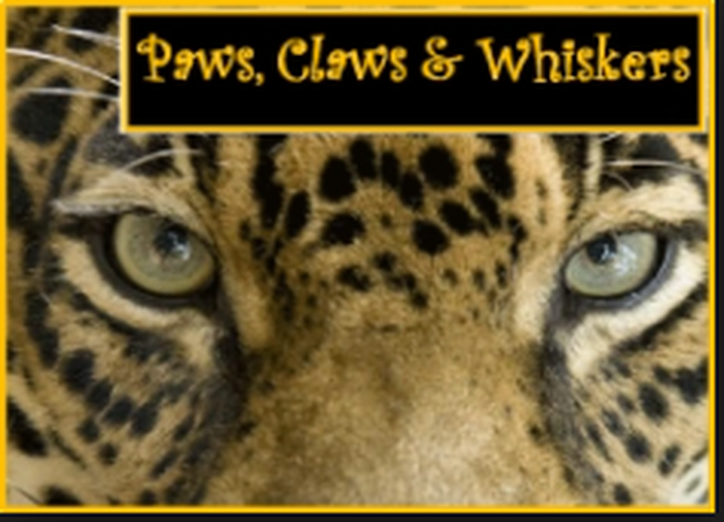

Underwater Class Topic Web

TERM 2 2024
EYFS Medium Term Planning, based on the characteristics of effective learning: - playing and exploring, active learning, creative and critical thinking

Maths: Number and Numerical Patterns
- Use numbers to 20 (and beyond) to solve calculations and number problems
- Identify one more/less than a given number, and number bonds to 10 (and then 20) i.e. 6+4, 8+2 etc
- Solve practical problems that involve combining groups of 2, 5 or 10, or sharing into equal groups
- Record and explain mathematical calculations/problem solving
- Use money at the role-play Christmas market stall: calculate totals of a variety of 1p-20p coins
- Explore pattern in animal skins and create our own
- Patterns in the environment

Understanding of the World
- Explore African safari footage; learn about the wild animals that live there, including differences and similarities
- Investigate and compare habitats, climate and landscapes, finding out through personal experience and through books
- Explore life in an African village and compare it to our local village and surrounding areas (including variations in diet)
- Begin to describe some actions within our immediate communities that help to maintain the area they live in
Expressive Arts & Design
- Print making and collage to make patterns based on the natural markings of animals
- Safely use and explore a variety of materials, tools and techniques, experimenting with colour, design, texture, form and function: - create patterns through printing/collage/clay, inspired by animal prints
- African inspired dance and movement: - use drums to beat out rhythms. Children to continue to explore, using upturned buckets etc.
- Talk about features of their own and others work, recognising the differences between them and the strengths of others
- Learn African call and response songs e.g. Kye key kule
- Participate and perform in the Nativity Play

